Setting up Postgresql JDBC Driver

*I use VS Code as my IDE, so all JAVA example images are for vs code. I use pgadmin 4 to access postgresql.

1. Create a new JAVA project in your IDE of choice using maven build tools.
   1. set up groupid and version to whatever you want and make note of the groupid
2. Download the driver from this [link](https://jdbc.postgresql.org/download/). Download the correct driver for the version of java you have installed, which is likely greater than java 8 so you can get the most recent driver. **Click the copy maven button**
   1. Add the dependency to maven dependenices
3. Add ascii table dependency to maven dependencies. Copy the maven dependency at this [link](https://github.com/vdmeer/asciitable/tree/master?tab=readme-ov-file#installation) and paste into maven dependencies

Ascii table maven dependency

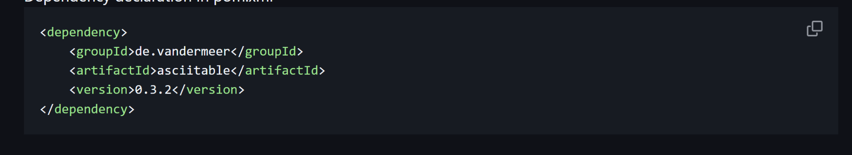

Image of dependencies

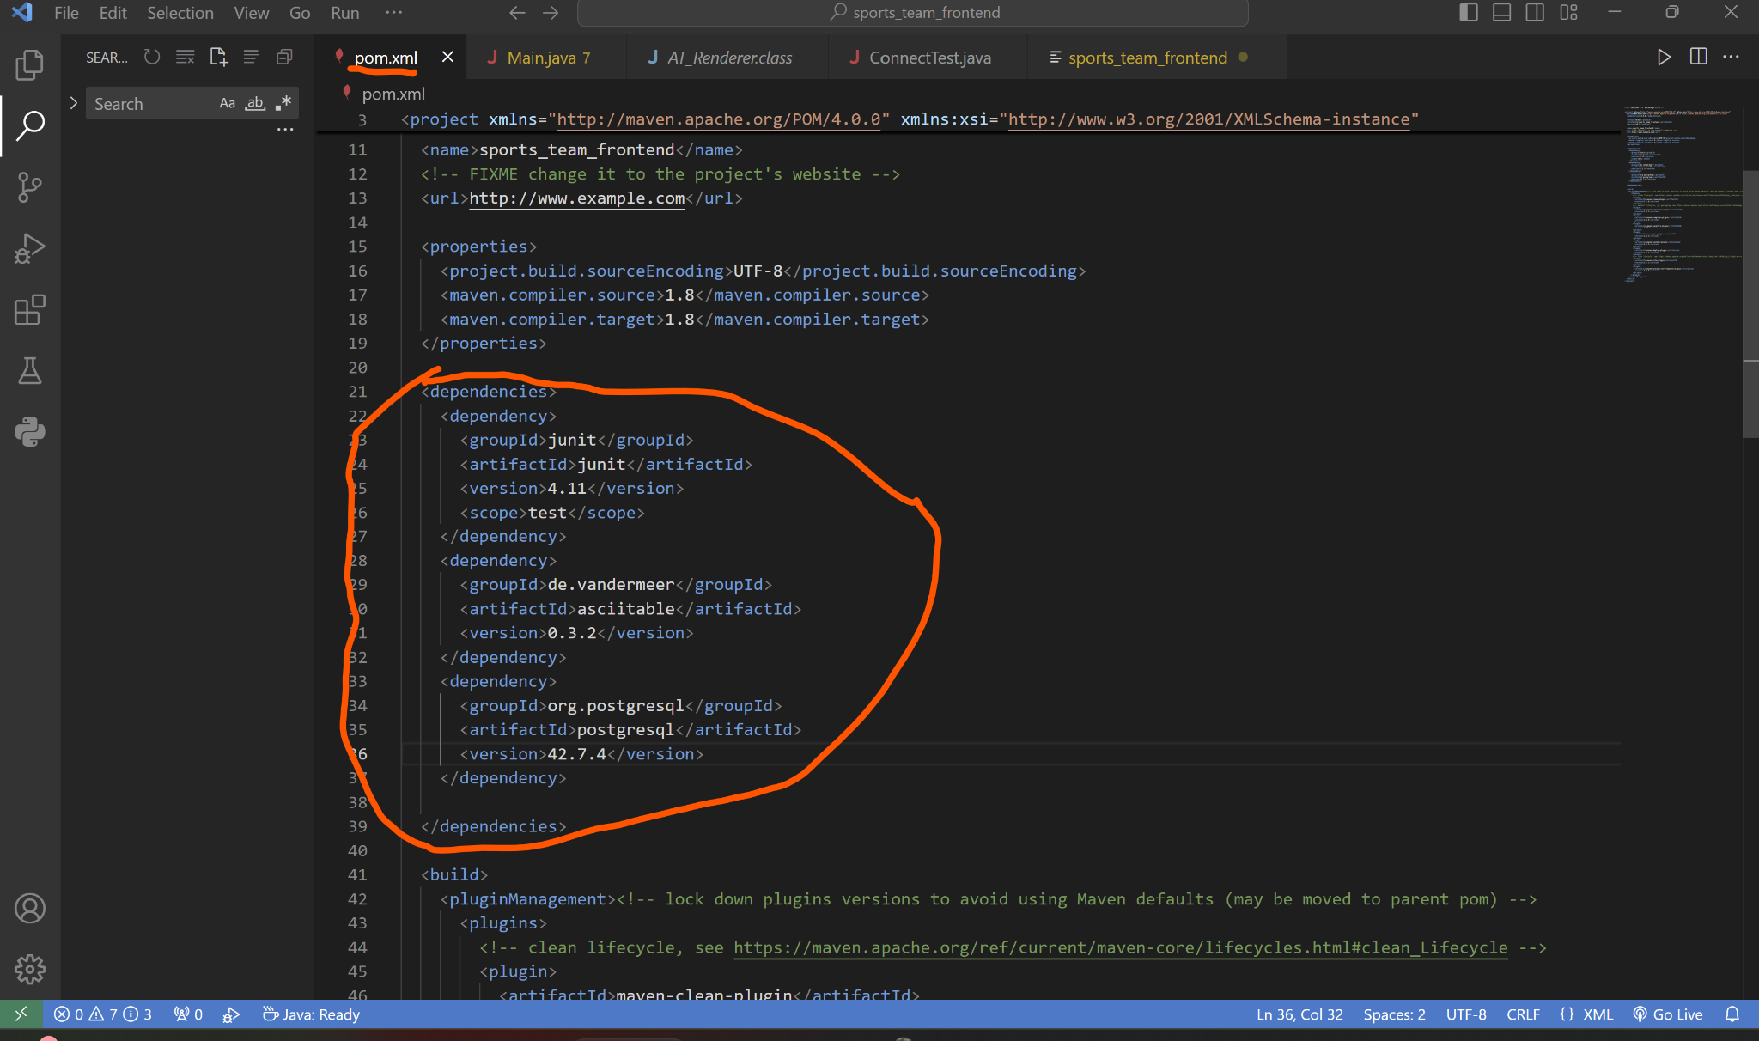

1. Create a user in postgresql using pgadmin4 or the command line. Reference images:

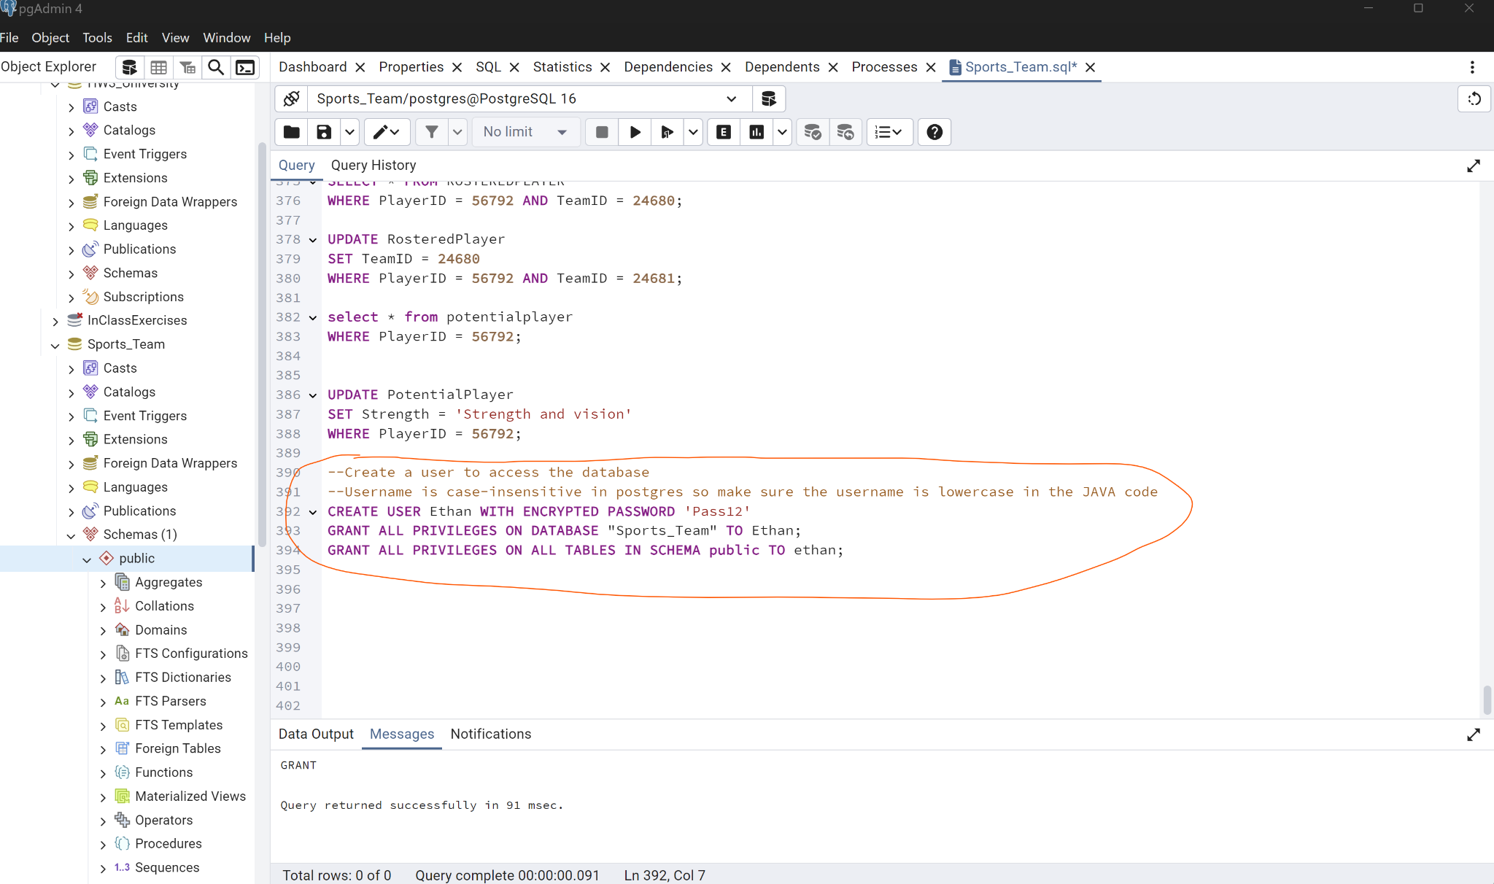

1. Download file **Main.java** from github and place it in your new JAVA project src directory.
2. Enter your created username and password when the program prompts.
3. The code should now work if you click **Run Java**